

**Table of Contents**

Executive summary 2

I. Introduction 2

II. Analytics 3

1. Summary the numbers of hours worked in IntelliAuto 3

2. Differences in hours worked in different categories 4

**a. Gender** 4

**b. Occupation** 4

**c. Awareness of industry 4** 5

3. Working hours relationship with another variable 6

**a. Age** 6

**b. Education years** 7

4. Distribution of workers in terms of gender across occupation 8

III. Finding and Discussion 9

1. Lack of diversity in workplace 9

2. Overload of working hours 9

3. Declining in the commitment of high educated employees 10

IV. Recommendations 11

1. Adopt gender-neutral recruitment and promotion policies 11

2. Offer flexible working arrangements 11

3. Regularly monitor and review work hours 11

4. Conduct regular surveys or focus group discussions with employees 11

Appendixs 12

References 17

**Executive summary**

*The-study-of employee profiles-and-working hours that was done in-the-context-of the most-recent collective-bargaining-agreement-between-IntelliAuto-and-the-unions is presented in this-report. The-research investigates differences in working hours by-gender, occupation-and-knowledge-of-Industry-4.0 using a subset of data supplied by the organization. Although there-are some variations in working-hours across these variables, the-findings show that the average-weekly working-hours are significantly greater-than-the-normal-of-37-working hours. This-result-raises questions about the readiness of-IntelliAuto for the shift to digital manufacturing as well as-employee-work-life balance, health, efficiency-and-task management. The study also looks at-how working-hours-relate to age-and-educational years of the-employees. Even though there is-no conclusive evidence that-they-are significantly-related to-working-hours. The-study, based on-qualitative-information, has-examines these variables' possible effects on workforce diversity, job growth, work-life balance, recruitment-and-retention. In-addition, the-research emphasizes-how the-distribution of men-and-women workers is unequal across all professions, which has a-detrimental effect on workforce-diversity-and-gender-equity-at-IntelliAuto. The-report ends with-suggestions for the-manager to-take-into-account for enhancing gender equity-and-work-life-balance in-the-company based on these-results.*

# **I. Introduction**

The-world of work is in a constant state of change-and-evolution, as organizations adapt to new-technologies, practices-and policies that influence the-way employees work. 47%-of-American-jobs, according-to-research by-Smith-(2016), are at danger of automation, signaling a major-change in-the-labor-market. According-to-Ross-and-Shroff-(2017), the-use of machinery in-the-past boosted output-and-income but also resulted in the displacement of human employees. The-use of technology to expand job possibilities, according-to-Acemoglu-(2021), may also be-detrimental to workers' rights-and-societal-wellbeing. For-instance, the-use of digital platforms-and-remote employment may increase the number of low-wage, unregulated-and-precarious-positions, which would be detrimental to employees' moral-and-legal rights-(Bergvall-and-Howcroft-2014).

Organizations are under tremendous pressure to maximise resources, boost output-and-advance-equity-and-diversity in-the-workplace-due-to-the quickly shifting economic-environment. Collective-bargaining-deals between-management-and-labour-groups are one-way-to accomplish these-goals. These-agreements can cover a-range-of topics, including pay, perks-and­-employment stability. We concentrate on two-important elements of-a recent-workplace-negotiating deal with the unions in-this-report, namely working hours-and-the-hiring-of-female-workers, for-the-reasons-listed-in-Appendix-1.

We examined a portion of the organisation's data in-order-to-evaluate-the-present state of-working-hours-and-gender-division-as-well-as-pinpoint areas that needed development. This-study examines variations in-working-hours based on-gender, occupation-and-knowledge-of-Industry 4.0 to analyse-organisational working-hours-and-employee-profiles. Additionally, we-looked into the distribution of men-and-women workers across various professions-together-with-the connection-between-working-hours and age, education years. We summarise the-main-conclusions from our-research-and-offer-commentary-on the highlighted problem-areas-and-possible-improvement areas-for-the-organisation. To-help-IntelliAuto-accomplish its strategic-goals-and-enhance its operations-and-labour-rights, our ultimate aim is to offer recommendations based on-solid-proof.

**II. Analytics**

## **1. Summary the numbers of hours worked in IntelliAuto**

For-the-best-accuracy, the measure of-Location, specifically-Median, is used in-order-to summarize the-number-of-working-hours-in-IntelliAuto-(Appendix-2-and-3). In-Figure-1, the-Median-value of the working-hours is-42, which indicates half of the employees in the IntelliAuto-company works more than-42-hours-per-week while the-company normal-working hours is 37-hours-per-week. This-means-in 50% of those employees, they worked 5-hours-per-week more than-the-standard-time.

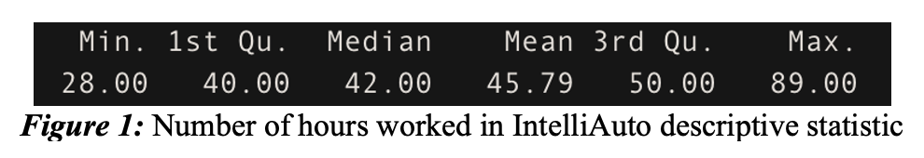

Besides-from-the-Median, the-Mode although is not the-best-measurement-of-location as the median, however, it-still-gives-us-some-meaningful-information by showing which working hours occurs most frequently in-our-dataset. According-to-the-Figure-2-and-Appendix-4, it is clear that a-large-portion of the staff at-IntelliAuto-(361-people-out-of-1000-people accounting-for-36%-of-all-employees)-work-40-hours-per-week, which also much higher-than-the-company normal-working-hours-(37-hours-per-week).

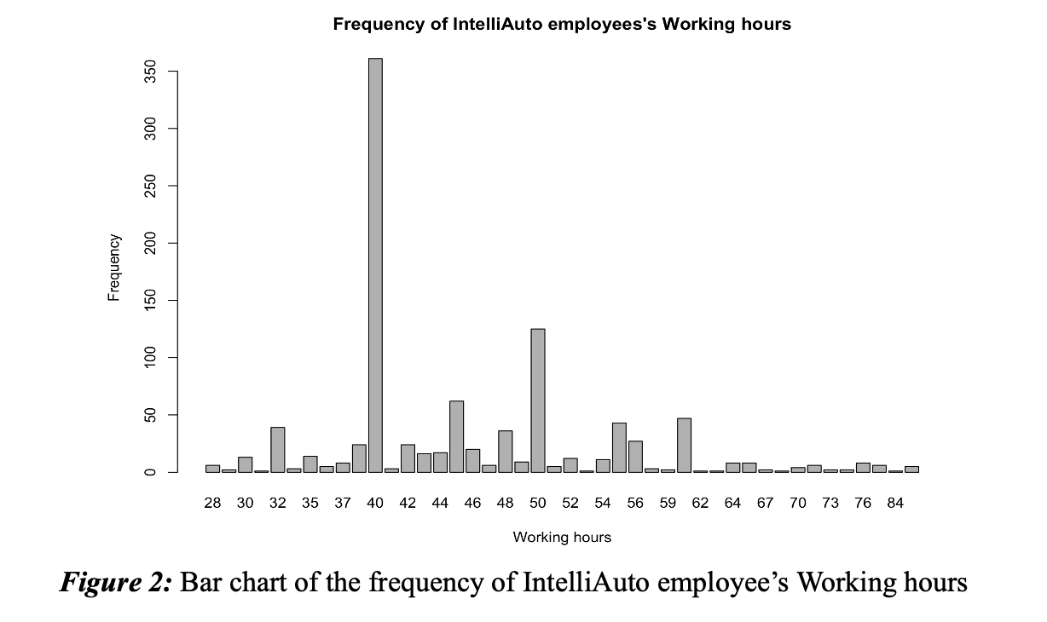

Furthermore, there still have some employees working-at-the maximum hours which is-89-hours per-week. This indicates that they work-52 hours overtime-per-week, which equates to-approximately-7.5-hours-per day-(include-weekend), compared-to-the-company's-standard-working-hours. But-at-the-same-time, about-8.3%-of-employees-work less than-37-hours-per-week, even the lowest is-28-hours-per-week-(Appendix-4).

## **2. Differences in hours worked in different categories**

### **a. Gender**

In-Figure 3, the-length of-Male employees’s working hours’s Box-and-Whisker plot is longer-than-that-of-Female, showing that-Male-employees's-working-hours data has more-variable-data and-every metric is-higher than-that-of-Female.

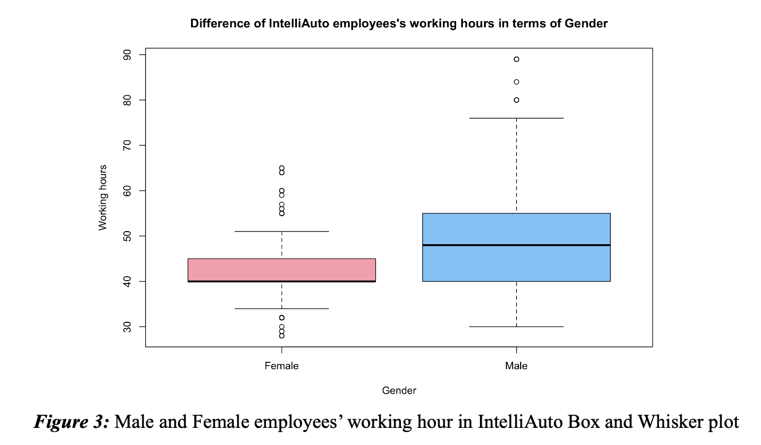

Accoding-to-the-Figure-3, the-figures for the most hours worked for the-week point towards the top of the-data, where the Male employees' working-hours observations vary most since it skews to the left (Apendix-5). In-contrast, the observations of Female-employees' working-hours tend to skew to the right, where-concentrated-values ​of low working-hours per week-(Appendix-5). Furthermore, the-outliers-in-the-two box plot shows that employees with the highest-number of hours worked in the-entire company, 89-hours-per-week, are male-employees, while the-people with the-lowest-number-of-hours-worked, 28-hours-per-week, are-female-employee. Therefore, the skewness as-well-as the-outliers of the-data also confirms that at IntelliAuto, the-working time-of the-week-for male-employees is significantly more than-that of-employees.

### **b. Occupation**

According-to-the-Figure 4, the-highest working-hours appear to be in-Technology/Sales position as the-median of working-hours in this occupation is much higher than-the others. The second-and third position belong to Professional-and-Laborer-occupation respectively-and-the-lowest-one is-in-Admin-support. Most-of the employees in the-Technology/Sales occupation work-around 50-hours-per-week-and-the-highest-is-89-hours-per-week while the-Admin-supporters-only-spend-40-hours-per-week with-the-minimum-of-28-hours-per-week. Besides, the-median-hours worked in-Admin-support, Service, Production-and-Management-are-the-same. However, working-hours-in-Production-have-much-greater-variability. Employees-working-in-the Production-position-might-have different hours-worked-per-week, from-very-low-to-very-high. Additionally, working-hours-per-week-have the-least variation in Admin-support.

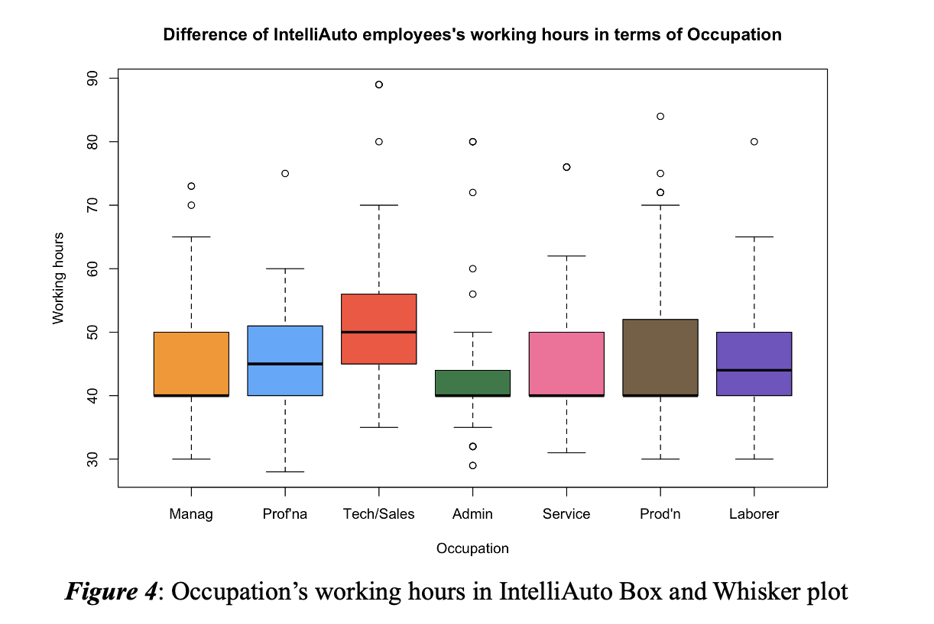

### **c. Awareness of industry 4**

As-shown-in-the-Figure-5, there-does-not-seem to be a significant difference in the number of-hours worked between-employees who are-aware-of-the-industry-4.0-and-those who-are-not. However, the-median value in those two-variables in-Figure-5 also point-out that while-employees concerning about-the-4.0 industry have-around-43-of-working-hours-per week, those-who-are not only-have-40-hours-per week. Furthermore, the-employee-with the-lowest working-hours of IntelliAuto, which-is 28 hours per week, is the-person with no-industry-4.0-knowledge. However, the-person-with-the-highest-working-hours, 98-hours-per-week, is-also the-one in this-group. Hence, the-working-hours data-for-the-group of unknown about the-industry-4.0 has-greater-variability, which-means the employees in-this-group-can work at the-lowest-or-highest-number-of-hours-even if-they-are-not-aware-of-industry-4.0.

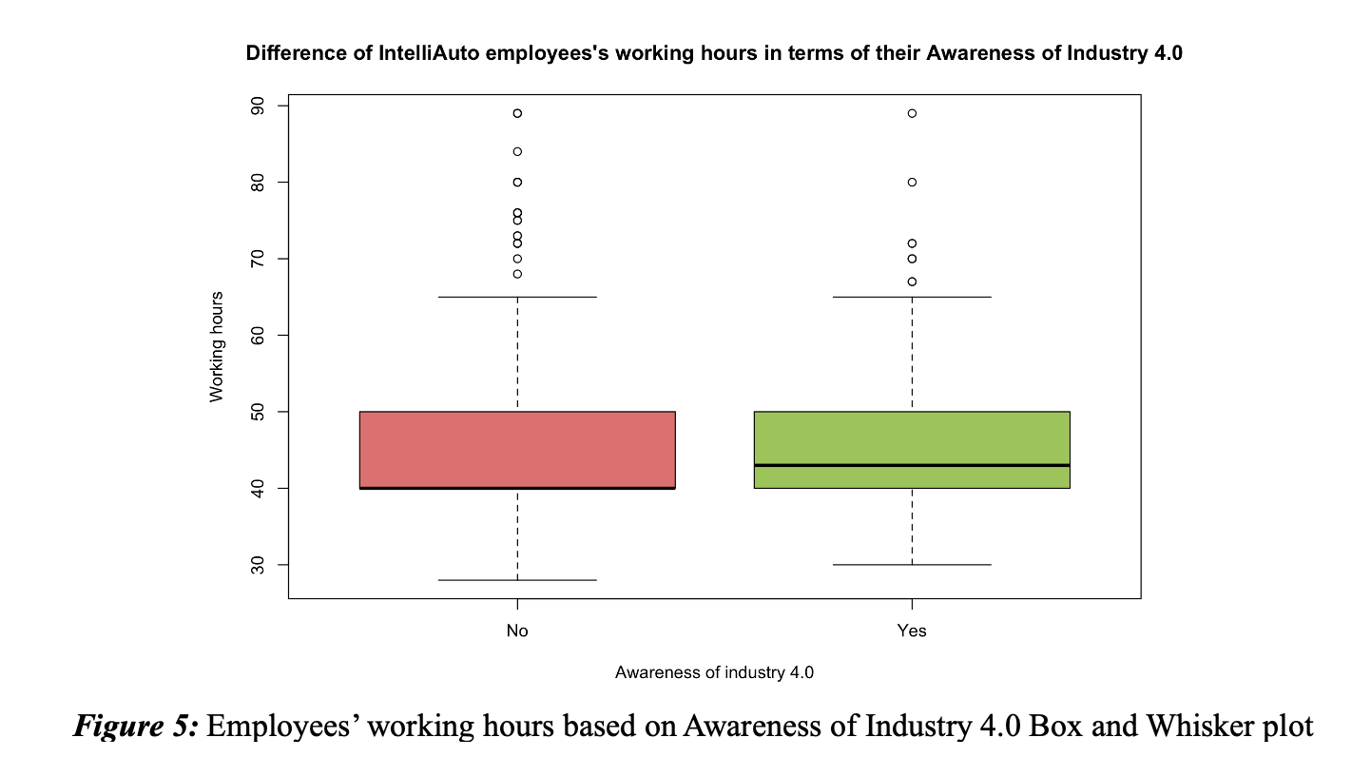

## **3. Working hours relationship with another variable**

### **a. Age**

The-scatter-plot-in-Figure-6 shows a negative-relationship between the-working-hours-and-the-age-of-employees-in-IntelliAuto-organization. Specifically, in-IntelliAuto, younger-employees-tend to work longer-hours than-olders-employees. Furthermore, the-correlation-coefficient-between those-two-variable equaling-to -0.093 also support for-this-result-(Figure-6). However, according-to-Camm-et-al. (2018), the -0.093-correlation-coefficient-value, which-is-nearly to-0, indicates a very weak-negative relationship-between-working-hours-and-ages. This-means that as-age increases, there-is a slight tendency for working-hours to decrease, but the-relationship is-not strong. However, according-to-Appendix-6, this-relationship-can-be-hold.

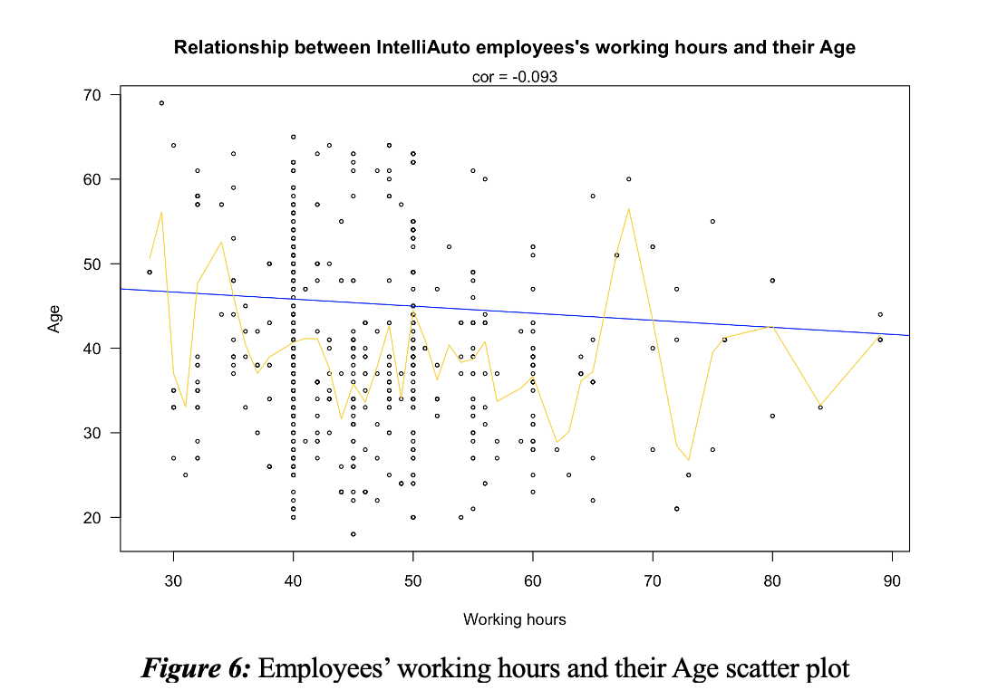

### **b. Education years**

Unlike-the-Age, the-Education-years variable shows no-relationship with the working hours of-the-employees in-IntelliAuto-organization. In-other-words, spending a-lot-of time-studying-in-schools does not increase-or-decrease the-working time of employees-at-this enterprise. Furthermore, the-correlation-coefficient of these two-variables also supports for our-analysis. Specifically, a-correlation-coefficient of-0.05-indicates a-very weak positive-relationship-between working-hours-and-education-years-(Figure-7). This-means that as the number of-education years increases, there-is a slight tendency for working-hours to increase, but the-relationship is-not strong, even-nonexistent. However, according-to-Appendix-6, there might be-association-between-these-two-variables.

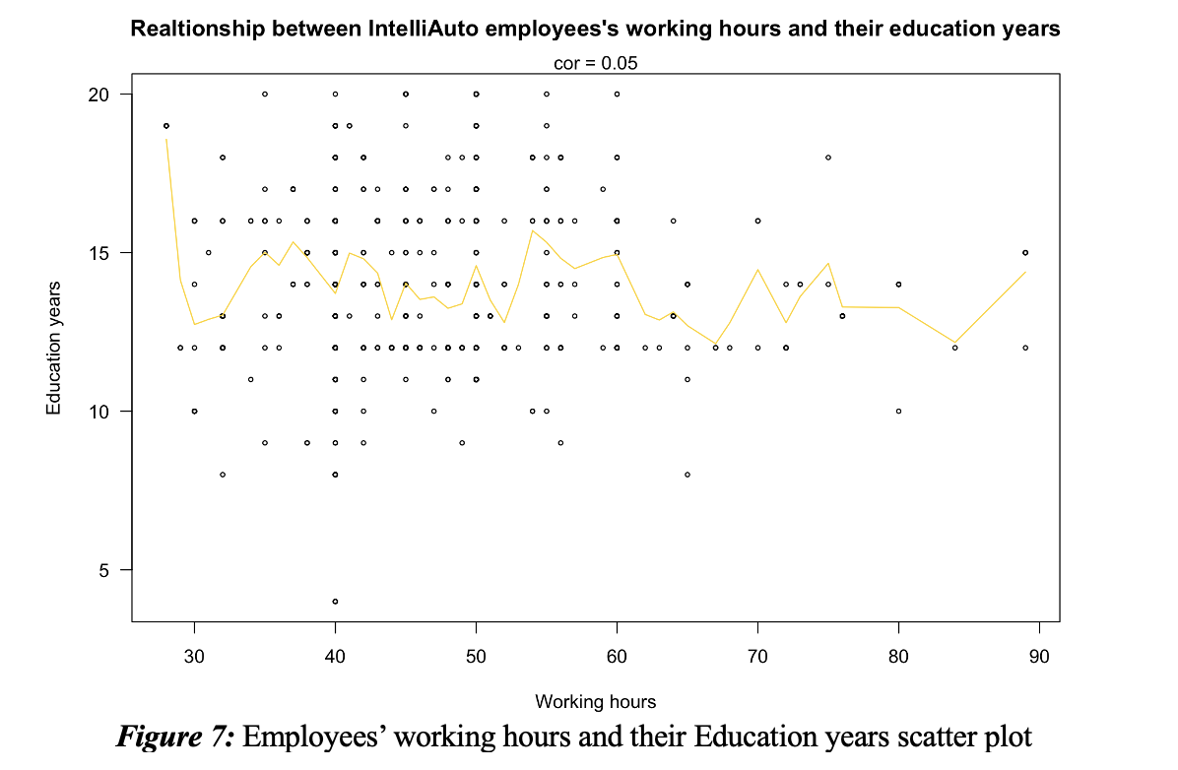

## **4. Distribution of workers in terms of gender across occupation**

By-looking-at-the-bar-chart-in-Figure-8, it-is-clear that the-number-of-male-employees-is-significantly-higher-than-that-of-female-employees-in-each-occupation except the Admin-support, which-indicates a-gender-imbalance-in-IntelliAuto-organization. The-Figure-8-also-gives-us-information-that-Production role have the-highest-concentration of male employees, but also the lowest concentration of female-employees. This is-in-contrast-to the-Admin-support-occupations since the-majority-of-female-employees while the percentage of male-employees is-low. Besides, the-Professional-position-seems to record the least disparity between male and-female employees. However, in-general, IntelliAuto has a-large-number-of-male-employees in-most-of-occupations-while female-employees record a-much lower-number.

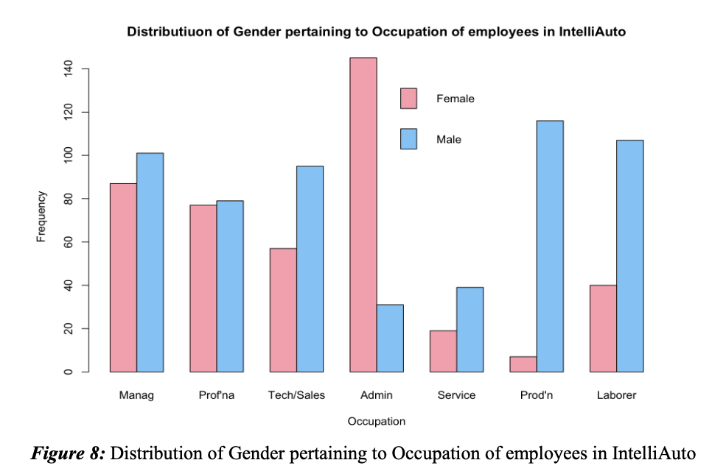

# **III. Finding and Discussion[1]**

## **1. Lack of diversity in workplace**

The distribution of male-and-female workers across various occupation together-with-the-fact-that male works-more-hours-than-female-is-unbalanced. This might be as a result of discriminatory hiring-and-advancement practices-(Dussault-and-Franceschini-2006). Male-workers are overrepresented-in Technology/sales role, whereas-female employees are overrepresented in Admin-assistance role. This-disparity could lead to a-lack-of equality-and-variety-in-the-workplace, which-could-have-an impact-on decision-making, decreased ingenuity-and-lower levels of invention-(Noronha-et-al. 2022). Additionally, a-dearth of inclusivity can result in decreased work happiness, higher-turnover rates-and-poorer-employee involvement-(Haller-et-al. 2016). Although-there have-several discussions proving that this imbalance-is-reasonable-(Appendix-8), however, with-the emerge of Industry-4.0 in-21st-century-society-together with the analysis suggest that the-proportion of female employees is lower in others-categories-compared-to-the Admin-support categories, there-is a need for targeted interventions-to promote the inclusivity in-organization.

## **2. Overload of working hours**

The organization’s typical workweek for all workers exceeds-the-standard-working-week-of-37-hours. The-lengthy-typical workweek across all occupational groups may be a factor in employee-burnout, a-decline-in job happiness-and-a-decline in output-(Brummelhuis-et-al. 2011). Previous-studies have-demonstrated that working-too-many hours can have a detrimental impact on a number of factors, including physical and emotional health-issues, decreased job happiness-and poorer productivity levels-(Poulsen-et-al. 2014). Long-work-hours may also result in work-family strife, which can have detrimental effects on both the work and home spheres-(Brummelhuis-et-al. 2011). Additionally, long-workdays-may be a sign of-inefficient time-management-and-inefficient-work-processes, which-can-result in unneeded tension-and-poor work-life-balance-(Khalid-et-al. 2021).

In-addition, the-negative-relationship-between-age-and-working-hours indicates that-younger-workers-typically-put-in-more hours-than-senior-workers, which might negatively-impact-to the-physical-and-emotional-health-of-young-workers. To-explain this disparity, Kanai-and-Wakabayashi-(2004) point out that young-workers may lack coping skills due to lack of-experience-or high-financial-constraints, so they volunteer to work longer-hours-than older-people.

## **3. Declining in the commitment of high educated employees**

Although not statistically significant, our-research had shown a correlation-between-employees' levels of schooling-and-their-job-hours. However, Appendix-6-and-the -journal-by-Jeon-et-al. (2020)-have demonstrated that the lengthier the academic-year, the-longer-the-working-week. And-this-relationship-would imply that there might be problems with employee-support-and-work-life-balance-within-the-IntelliAuto-company, both-for-specific-workers-and for-the-as-a organization-whole.

Higher-educated-workers may experience personal pressure to put in more hours to demonstrate-their worth-and-advance their jobs-(White-et-al. 2003). This-pressure may be caused by a variety-of things, such-as rivalry with other highly-educated coworkers, a desire for reward-and-acknowledgment-or-simply the conviction that putting in more hours will help one thrive in the-organization-(Kinman-2010). Employees may eventually experience fatigue, worry-and-decreased output-as-they battle to combine their work obligations with-their personal and family-obligations-(McNamara-and-Liyanarachchi-2008).

The-effects of overworking highly educated workers can be felt at the organisational level. For-instance, it-might-result-in-greater-turnover rates among-these workers as-they look for-companies who provide better assistance-and-work-life balance-(Nijhof-et-al. 1998). This could-then result in a dearth of skilled applicants-on-the-job market, making it more challenging for the-organization to meet its staffing requirements and accomplish its objectives-(Chen-and-Francesco-2000). Additionally, overworked-staff-members may be more likely to make mistakes-or experience health issues, which could-have-a-detrimental effect-on-the-effectiveness-and-reputation-of-the-company-(Wolff-1981).

Additionally, the-research indicates that-older-workers-may work-fewer-hours-than-younger workers, which may-be-a result of age-related-biases-or-obstacles in-the-company's practises-for hiring, retaining-or-promoting employees. Due-to-this, older workers may have fewer chances to-advance their jobs-and-provide the-company with useful knowledge-and-expertise-(Oostrom-et-al. 2016).

# **IV. Recommendations[2]**

## **1. Adopt gender-neutral recruitment and promotion policies**

The-business-should implement gender-neutral hiring-and-advancement procedures to handle the-gender-gap in various occupational-categories-(Tiainen-2019). Specific goals for the-proportion of female-employees in each occupational group should-be established in these-policies-and-success should be routinely tracked. The-basis for hiring-and-promoting people-should-be their abilities-and-ability, not-their-gender-(Foley-and-Willamson-2018). Equal-training-and-growth chances for male-and-female employees should be provided by the-organization. Gender-neutral workplace rules can encourage inclusion and variety, which can-result in more creative-problem-solving, better decision-making-and greater employee-happiness-(Tiainen-2019).

## **2. Offer flexible working arrangements**

The-company should provide flexible-working options, such as part-time work, task sharing-or-outsourcing, to lessen the negative-effects of lengthy work hours. By-doing-so, workers can-better manage their personal and professional lives and lower their risk of exhaustion-(Maxwell-et-al. 2007). Flexible work schedules may also draw more female-workers who need to juggle-job-and-family-obligations. The-company should urge staff to take advantage of flexible working options by making clear communications-about their-availability. The company can improve the-efficiency-and-well-being of its employees by offering flexible work choices-(Maxwell-et-al-2007).

## **3. Regularly monitor and review work hours**

The-company-should-routinely watch-and-review worked-hours to ensure that-workers are not-overworked. This-may entail-establishing weekly-time limits-or-putting in-place-a method to-monitor-individual-work-hours. Any-instances of work hour policy-infractions should-be-handled right away. The-company can spot places where workloads may be too heavy and take-action-to more-effectively redistribute-work by keeping track of work hours-(Feldman-2002). Additionally, this-approach can-restrict-the capacity of poor-health, performance-and-job-satisfaction-and-prevent workers from working-long hours.

## **4. Conduct regular surveys or focus group discussions with employees**

The-company-should regularly survey its-staffs-or-hold-focus-groups to get-their-input on how-well implemented solutions are-working-and-to spot any new issues-or-concerns. This can help-inform future decisions-and-offer-insightful information about the wants and worries of workers. Work hours, employment satisfaction, work-life balance, diversity, inclusion-and-other-subjects-should be covered-in-the surveys-or-talks. The-company should also let the staff know the-findings of the polls-or-communications-and-take action-to resolve-any-problems-that were-found. Since-women-are-known to experience a "double-work-burden," this-technique-can-be-used to better understand their-context, workers' preferences, present-job-satisfaction-and-ambitions-(Appendix-8).

# **Appendix**

**Appendix 1: Why focusing on analysing the working hours and the employment of female employees?**

Our report believe that accessing, understanding and developing policies related to these two issues is a favorable first step for the sustainable development of IntelliAuto in the industrial age 4.0 since working hours as well as the inclusive have a significant impact on employee well-being, productivity, fairness and overall organizational performance.

**Appenidx 2: Choose the best Descriptive Statistic**

According to the Doksum (1975), the measures of Location describe the average or the typical of the given dataset. Results drawn from the measures of central tendency show whether most of data points lie (Doksum 1975). On the other hands, measures of Variability describe the diversity or dispersion in the distribution of the given dataset (Katnelson and Kotz 1957). Additionally, the Box and whisker plot is a graphic representation of a range, interquartile range, and the median of a given dataset, from which the overall shape, the skewness of the data distribution is illustrates. All three methods are useful for data analysis as well as prediction (Li et al. 2011). However, in this case, because the weekly working hours of IntellAuto employees need to be correctly presented for analysis and comparison, the measure of Location is more preferable than the other two.

**Appendix 3: Choose the best Measure of Location**

As illustrated in the Figure 9, there are number of outliers appears in our Working hours variable of the data set as well as our data is right - skewness. The existence of outliers and the skewness would reallocate the results close to the outliers, which directly affects the accuracy of the analysis (Camm et al. 2018). Thus, Mean is not an ideal approach to investigate the data due to its sensitive to the outliers despite of being considered to be the most accurate measurement (Camm et al. 2018). Hence, Median is indicated to be the most effective measure of Location in the analysis of the Working hours of IntelliAuto employees.

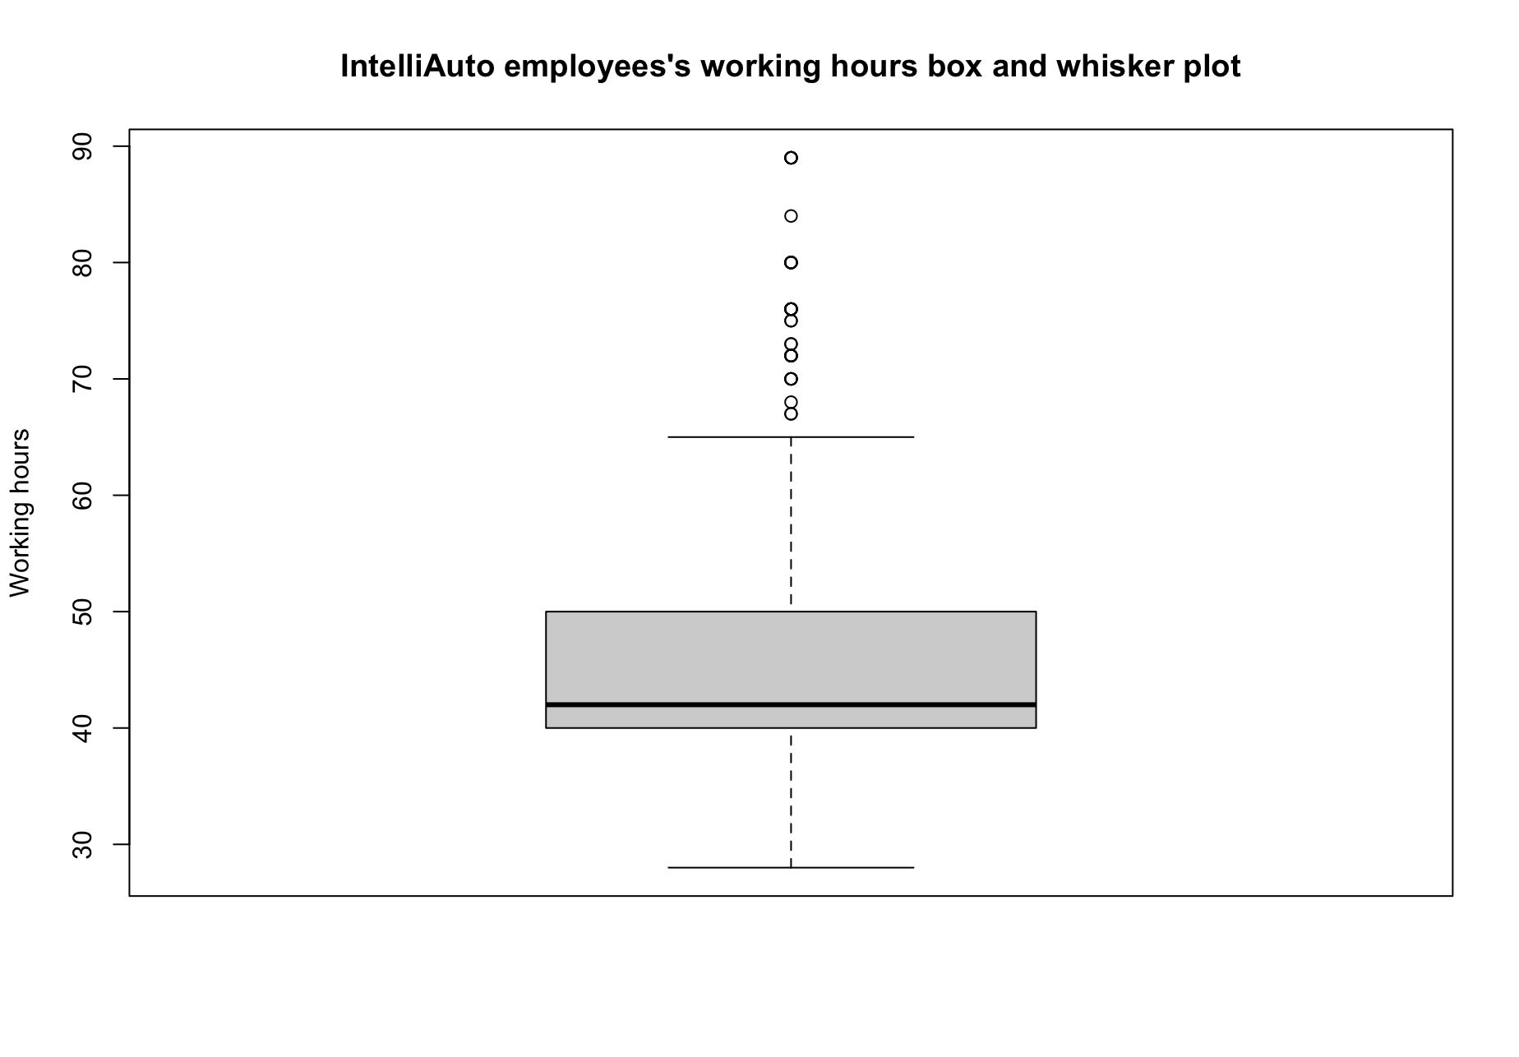

***Figure 9:*** IntelliAuto employees’ working hours Box and Whisker plot

**Appendix 4: Working hours frequency in IntelliAuto organization**

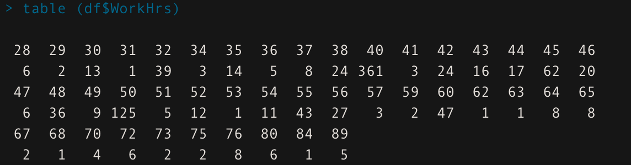

***Figure 10:*** Working hours frequency in IntelliAuto organization

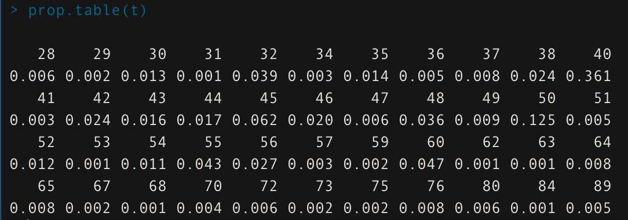

***Figure 11*:** Working hours frequency in IntelliAuto organization (%)

**Appendix 5: The skewness of Male and Female working hours data**

In the case of Male, the distance between Q1 and the median in the box is larger than the distance between Q3 and the median. Furthermore, the median is greater than the mean. Hence, the majority of the values are asymmetrically distributed and tend to stretch primarily on the right side. Differently, the distance from median to Q1 in the Female working hours box is less than the distance from Q3 to median, indicating that the data's mean is greater than its median. Thus, the Female working hours’ box plot is positively skewed to the right while the Male is skewed to the left.

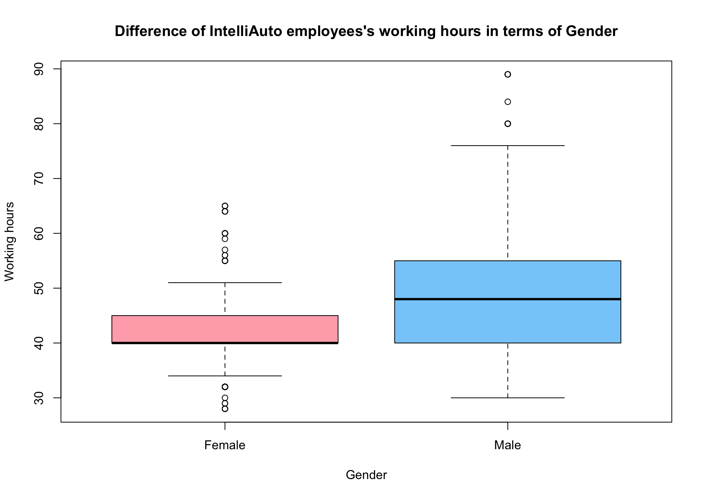

***Figure 12:*** Male and Female employees’ working hour in IntelliAuto Box and Whisker plot

**Appendix 6: Correlation does not imply causation discussion**

**1. Working hours relationship with Age**

According to Barrowman (2014), there may be other variables that influence the connection between working hours and age. Correlation does not always indicate causation. For instance, older people may have different goals and preferences when it comes to their jobs than younger people, or they may have health problems that make it difficult for them to work extended hours (Lockenhoff and Cartensen 2004). Additionally, various sectors or occupations may have varying age-related working hour patterns. For example, consulting jobs may provide senior employees with more flexible work schedules (Clark 1997). As a result, the figure that links working hours to employee age at IntelliAuto may actually be negative. However, it is vital to consider other factors that may be influencing the relationship between those two variables when interpreting the relationship (correlation coefficient).

**2.** **Working hours relationship with Education years**

The connection between working hours and educational years could be influenced by other variables, as was already stated since correlation does not indicate causation. For instance, employees with more education may place a higher value on work-life harmony and may be more motivated to seek out positions with more flexible schedules or better work-life choices (Cannizzo et al. 2018). Higher education may also result in more abilities and productivity, which could result in more effective work and shorter job completion times (Crews and Russ 2020). The sort of employment and the industry can also have a big impact on how long people work and how long they spend in school (Lingard et al. 2012). For instance, poorer educational standards and extended working hours may be found in sectors like retail or the food service industry. In comparison, healthcare positions can involve lengthy and irregular working hours and call for a higher level of education, such as a nursing or medical degree. The opportunity for more free hours or a shift into managerial or research positions with more consistent hours, however, may also result from higher levels of education in the healthcare industry.

**Appendix 7: Another challenge and solution for IntelliAuto**

**1. Challenge: Lack of Industry 4.0 awareness**

Our analysis although indicates a significant proportion of employees are not aware of Industry 4.0 technologies and also suggests a potential gap in the company's workforce development and training initiatives. This could limit the organization's ability to remain competitive and innovative in a rapidly evolving technological landscape. According to Spencer (2018), automation that uses AI and robots with AI technology may increase production productivity and bring new human tasks and abilities. However, since machines are anticipated to work swiftly, cheaply and effectively with both working class responsibilities and white-collar jobs, using AI can prevent untrained people from depending on predictable or dull jobs (Ross and Shroff 2017). According to Spencer (2018), technology has bound the workers rather than liberated them. Additionally, Acemoglu (2021) asserted that the employment of unskilled employees may be threatened by machines taking over many repetitious and routine tasks. The difference between the affluent and the impoverished is also widening in a society where people who are unable to make a profit are seen as worthless and where robots are quickly replacing human work (Spencer 2018).

**2. Solution:** **Training program to educate and develop staff skills**

In order to increase their flexibility and fight successfully in the workforce, managers of businesses should develop a new capacity development plan for workers that encourages them to improve their existing skill set and pick up new transferrable talents (Jackson 2010). Employees are required to measure their total training hours so that management can monitor their growth and motivate them to regularly engage in the professional development plan. Managers must ensure that the atmosphere is favourable to learning in order to support company development and use technology to increase output and productivity. A appropriate policy should also be in place if someone wishes to replace a work responsibility with a machine or eliminate it altogether. These initiatives will help workers develop a certain set of skills that will enable them to boldly incorporate into the 4.0 age rather than falling behind or being displaced, which will also give the company a competitive edge by greatly increasing business efficiency levels and market success.

There are some companies has successfully in applied this solution:

**IBM:** A comprehensive training and development programme is offered by this technology business, and it includes online learning materials, in-person training workshops, and mentoring opportunities. They also pay workers' fees when they pursue higher education (IBM 2021).

**Adobe:** This software business regularly offers its employees chances for skill development and upskilling, including classroom and online training courses. Additionally, they have a programme called "Kickbox" that offers staff members funding and tools to create and present original company ideas (Adobe 2021).

**Appendix 8: Argument among inequity in terms of Genders in workplace**

When compared to their male peers, women are said to have a considerably lower Working ability index (WAI) (Camerino et al 2006). This variation might be connected to gender norms. (Musshauser et al 2006). In particular, the economic and societal positions that a community deems suitable for men and women, according to Musshauser et al. (2006). In addition, Musshauser et al. (2006) referred to all societal variables that vary between men and women based on their designated gender roles as "gender-coded factors." For instance, women handle a larger proportion of household duties like babysitting, cooking, cleaning, etc. Therefore, differences between men and women's performance at work may result from the ongoing gender gap in household labour (Strandiz and Bammer 2004).

In addition, scholarly research has suggested that gender imbalances in the workplace may be influenced by the distinctive features of various types of work. Specifically, physically demanding manual jobs such as those found in warehousing or construction may offer fewer opportunities to women, who are often stereotyped as weaker, resulting in fewer hours worked by female employees. Additionally, married women may need to take prolonged absences from work, lasting from two to three months, to accommodate childbirth and childcare responsibilities (Ugreninov 2012). Furthermore, some women may experience postpartum depression, which can result in extended absences from work or leaving their job (Pearlstein et al 2009).

Female employees typically bear a "double work burden" due to their concurrent involvement in a paid job and a larger portion or full obligation of the household load (Rotenberg et al. 2008). As a result, when examining any gender-related factors, it is essential to take into account the gender wage gap (Artazcoz et al 2001).

**Appendix 9: Example of successful company apply the recommendations**

**1. Adopt gender-neutral recruitment and promotion policies**

**Patagonia:** To help workers manage work and family obligations, this outdoor apparel business has adopted a number of flexible work policies, including job sharing, telecommuting, and flexible scheduling. A company-wide objective to achieve female parity in all employment classifications by 2025 has also been established (Patagonia nd).

**Deloitte**: This professional services company has put in place a program called "Mass career customization." which enables employees to tailor their professional lives based on their unique requirements and goals. This involves, among other things, work sharing, flexible timing, and shorter hours (Benko and Weisberg 2008).

**2 and 3. Offer flexible working arrangements and regularly monitor and review work hours**

**Basecamp:** A 40-hour work week strategy has been adopted by this project management software business, limiting employee work hours to 8 hours per day with no weekend or holiday work. All workers are also given a limitless amount of compensated vacation time (Connley 2017).

**REI:** In order to encourage work-life harmony, this outdoor gear store has put in place a number of policies, such as flexible scheduling, job sharing, and a "no email after hours" rule. They also urge staff members to utilize vacation time to engage in outdoor pursuits.

## **4. Conduct regular surveys or focus group discussions with employees**

**Salesforce:** In order to promote gender diversity, this software business has put in place a number of policies, such as ongoing diversity and inclusion training, networking and mentorship opportunities for women, and a dedication to equitable compensation for similar work (Grigorian 2021).

**McKinsey & Company:** In order to promote diversity and inclusion, this management consulting company has put in place a number of initiatives, such as focused recruitment campaigns, mentoring programmes for underrepresented groups, and a dedication to raising the proportion of women in senior positions (Krivkovich and Yee 2022).

# These businesses have been able to improve efficiency and creativity while attracting and retaining spacious individuals by putting these suggestions into practice. This has also improved company performance in general.

# **References**

Acemoglu D (2021) *To reverse widening inequality, keep a tight rein on automation*, International Monetary Fund website, accessed 20 March 2023. <https://www.imf.org/external/pubs/ft/fandd/2021/03/COVID-inequality-and-automation-acemoglu.htm>

Adobe (2021) *Adobe Corporate Social Responsibility Report 2021*, Adobe website, accessed 19 March 2023. https://www.adobe.com/content/dam/cc/en/corporate-responsibility/pdfs/Adobe-CSR-Report-2021.pdf.

*American Journal of Obstetrics and Gynecology*, 200(4):357-364, <https://doi.org/10.1016/j.ajog.2008.11.033>.

Artazcoz L, Borrell C and Benach J (2001), ‘Gender inequalities in health among workers: the relation with family demands’, *Journal Epidemiol Community Health*, 55:639-647.

Barrowman N (2014), “Correlation, Causation, and Confusion”, 43:23-44.

Bergvall BK and Howcroft D (2014) ‘Amazon Mechanical Turk and the commodification of labour’, *New Technology, Work and Employment*, 29(3):213-223, <https://doi.org/10.1111/ntwe.12038>.

Brummelhuis LL, Hoeven CL, Bakker AB and Peper B (2011), “Breaking through the loss cycle of burnout: The role of motivation”, *Journal of Occupational and Organizational Psychology*, 84(2):268-287, <https://doi.org/10.1111/j.2044-8325.2011.02019>.

Camerino D, Conway PM, Heijden BV, Behar ME, Consonni D, Gould D and Hasselhorn HM (2006), ‘Low-perceived work ability, ageing and intention to leave nursing: a comparison among 10 European countries’, *Journal of Advanced Nursing*, 56(5):542-552, <https://doi.org/10.1111/j.1365-2648.2006.04046.x>.

Camm JD, Cochran JJ, Fry MJ, Ohlmann JW, Anderson DR, Sweeney DJ and Williams TA (2018) *Business Analytics*, 3 edn, Cengage Learning, Canada.

Cannizzo F, Mauri C and Osbaldiston N (2019), “Moral barriers between work/life balance policy and practice in academia”, *Journal of Cultural Economy*, 12(4):251-264, <https://doi.org/10.1080/17530350.2019.1605400>.

Chen ZX and Francesco AM (2000), “Employee Demography, Organizational Commitment, and Turnover Intentions in China: Do Cultural Differences Matter?”, *Human Relations*, 53(6), <https://doi.org/10.1177/0018726700536005>.

Clark AE (1997), “Job satisfaction and gender: Why are women so happy at work?”, *Labour Economics*, 4(4):341-372, <https://doi.org/10.1016/S0927-5371(97)00010-9>.

Connley C (2017) *Why the CEO of Basecamp only allows employees to work 32 hours a week*, CNBC website, accessed 19 March 2023. https://www.cnbc.com/2017/08/03/the-ceo-of-basecamp-only-allows-employees-to-put-in-a-32-hour-workweek.html.

Crews DE and Russ MJ (2020), “The impact of individual differences on multitasking ability”, *International Journal of Productivity and Performance Management*, 69(6):1301-1319, <https://doi.org/10.1108/IJPPM-04-2019-0191>.

Benko C and Weisberg A (2008) *Mass Career CustoMization: Building the Corporate Lattice organization*, Deloitee website, accessed 19 March 2023. https://www2.deloitte.com/content/dam/insights/us/articles/mass-career-customization-building-the-corporate-lattice-organization/US_deloittereview_MassCareerCustomization_jul08.pdf.

Doksum KA (1975), “Measures of Location and Asymmetry”, *Scandinavian Journal of Statistics*, 2(1):11-22.

Dussault G and Franceschini MC (2006), ‘Not enough there, too many here: understanding geographical imbalances in the distribution of the health workforce’, *Human Resources for Health*.

Feldman DC (2002), “Managers' propensity to work longer hours: A multilevel analysis”, *Human Resource Management Review*, 12(3):339-357, <https://doi.org/10.1016/S1053-4822(02)00064-5>.

Foley M and Williamson S (2018), “Managerial Perspectives on Implicit Bias, Affirmative Action, and Merit”, *Public Administration Review*, 79(1): 35-45, <https://doi.org/10.1111/puar.12955>.

Haller G, Delhumeau C, Mamie C, Zoccatelli and Clergue F (2016), ‘Gender difference in career advancement and job satisfaction in anaesthesia: a cross-sectional study’, *European Journal of Anaesthesiology*, 33(8):588-590, 10.1097/EJA.0000000000000471.

IBM (2021) *IBM ESG Report*, IBM Website, accessed 19 March 2023. https://www.ibm.com/impact/files/reports-policies/2021/IBM_2021_ESG_Report.pdf

Jackson D (2010) ‘An international profile of industry-relevant competencies and skill gaps in modern graduates’, *The International Journal of Management Education*, 8(3):29-58, doi.org/10.3794/ijme.83.288.

Jeon J, Lee W, Choi W, Ham S and Kang SK (2020), “Association between Working Hours and Self-Rated Health”, *International Journal of Environment Research and Public Health*, 17(8):27-36, <https://doi.org/10.3390/ijerph17082736>.

Kani A and Wakabayashi M (2004), “Effects of economic environmental changes on job demands and workaholism in Japan", *Journal of Organizational Change Management*, 17(5):537-548, <https://doi.org/10.1108/09534810410554533>.

Katsnelson J and Kotz (1975), “On the upper limits of some measures of variability”, 8:103-107, <https://doi.org/10.1007/BF02260299>.

Khalid J, Weng QD, Lugman A, Rasheed MI and Hina M (2021), “After-hours work-related technology use and individuals' deviance: The role of interruption overload, psychological transition and task closure”, *Kybernetes*, 55(1):158-181, <https://doi.org/10.1108/K-05-2020-0304>.

Kinam G (2010), “Pressure Points: A review of research on stressors and strains in UK academics”, *Educational Psychology*, 21(4):473-492, <https://doi.org/10.1080/01443410120090849>.

Krivkovich A and Yee L (2022) *Women in the Workplace 2022*, McKinsey & Company website, accessed 19 March 2023. https://www.mckinsey.com/featured-insights/diversity-and-inclusion/women-in-the-workplace.

Li DC, Chen CC, Chang CJ and Chen WC (2012), “Employing box-and-whisker plots for learning more knowledge in TFT-LCD pilot runs”, *International Journal of Production Research*, 50(6):1539-1553, <https://doi.org/10.1080/00207543.2011.555430>.

Lingard H, Francis V and Turner M (2012), “Work time demands, work time control and supervisor support in the Australian construction industry: An analysis of work‐family interaction”, *Engineering, Construction and Architectural Management*, 19(6):647-665, <https://doi.org/10.1108/09699981211277559>.

Lockenhoff CE and Carstensen LL (2004), “Socioemotional Selectivity Theory, Aging, and Health: The Increasingly Delicate Balance Between Regulating Emotions and Making Tough Choices”, *Journal of Personality*, 72(6):1395-1424, <https://doi.org/10.1111/j.1467-6494.2004.00301>.

Maxell G, Rankine L, Bell S and MacVicar A (2007), “The incidence and impact of flexible working arrangements in smaller businesses”, *Employee Relations*, 29(2):138-161, <https://doi.org/10.1108/01425450710719987>.

McNamara SM and Liyanarachchi GA (2008), “Time budget pressure and auditor dysfunctional behaviour within an occupational stress model”, *Accountancy Business and the Public Interest*, 7(1).

Musshauser D, Bader A, Wildt B and Hochleitner M (2006), ‘The impact of sociodemographic factors vs. gender roles on female hospital workers’ health: do we need to shift emphasis?’, *Journal of Occupational Health*, 48:383-391.

Noronha B, Fuchs A, Zdravkovic M and Estilia JB (2022), “Gender balance in the medical workplace – A snapshot into anesthesia”, *Trends in Anaesthesia and Critical Care*, 43:4-10, <https://doi.org/10.1016/j.tacc.2022.02.004>.

Oostrom JK, Pennings M and Bal PM (2016), “How do idiosyncratic deals contribute to the employability of older workers?”, Career Development International, 22(2):176-192, <https://doi.org/10.1108/CDI-08-2015-0112>.

Patagonia (nd) *Cultural/Life*, Patogonia50 website, accessed 19 March 2023. https://www.patagonia.com/culture.html.

Pearlstein T, Howard M, Salibury A and Zlotnick C (2009), “Postpartum depression”,

Poulsen AA, Meredith P and Khan SR (2014), “Burnout and Work Engagement in Occupational Therapists”, British Journal of Occupatuional Therapy, 77(3), <https://doi.org/10.4276/030802214X13941036266621>.

Ross G and Shroff Z (2017) ‘What will happen to the jobs? Technology-enabled productivity improvement – good for some, bad for others’, *Labour and Industry*, 27(3):165-192, <https://doi.org/10.1080/10301763.2017.1359817>.

Sassoon G (2021) *Report: Making Australia’s Workforce Digitally Ready*, The 360 blog webisite, accessed 19 March 2023. https://www.salesforce.com/au/blog/report-making-australias-workforce-digitally-ready/.

Smith A (2016) *Public predictions for the future of workforce automation*, Pew Research Center website, accessed 20 March 2023. <https://www.pewresearch.org/internet/2016/03/10/public-predictions-for-the-future-of-workforce-automation/>

Spencer DA (2018) ‘Fear and hope in an age of mass automation: debating the future of work’, *New Technology, Work and Employment*, 33(1):1-12, <https://doi.org/10.1111/ntwe.12105>.

Strazdins L and Bammer G (2004), “Women, work and musculoskeletal health”, *Social Science and Medicine*, 58(6):997-1005, <https://doi.org/10.1016/S0277-9536(03)00260-0>.

Tiainien T and Berki E (2019), “The re-production process of gender bias: A case of ICT professors through recruitment in a gender-neutral country”, *Studies in Higher Education*, 44(1):170-184, <https://doi.org/10.1080/03075079.2017.1351428>.

Ugreninov E (2012), “Can Family Policy Reduce Mothers’ Sick Leave Absence? A Causal Analysis of the Norwegian Paternity Leave Reform”, *Journal of Family and Economic Issues*, 34:435-446.

White M, Hill S, McGovern P, Mills C and Smeaton D (2003), “‘High-performance’ Management Practices, Working Hours and Work–Life Balance”, *British Journal of Industrial Relations*, 41(2):175-195, <https://doi.org/10.1111/1467-8543.00268>.

Wolff MF (2016), “Managers at Work: The Case of the Overworked Research Director”, *Research Management*, 24(5):8-10, <https://doi.org/10.1080/00345334.1981.11756683>.

1. These finding and discussion is focus on the two aspects that being agree between the enterprise and unions as mention at the introduction, which are working hours and increasing the numbers of female employees. However, there is a challenge explained in the Appendix 7 that I believe IntelliAuto might meet in the future. And together with that is the solution.
2. Based on the analysis conducted, the following recommendations are proposed to address the issues identified. These recommendations align with current research on organizational practices that promote diversity, equity and inclusion; enhance employee well-being and increase organizational performance. By adopting these recommendations, the organization can promote a culture of inclusivity, productivity and innovation, while fulfilling the goals set out in the enterprise bargaining agreement. Furthermore, examples of specific companies have applied those recommendations are displayed in Appendix 9.